**High Priority (Essential for Piloting)**

[x] Remove sound **for positive feedback** in phase 2 (sound for the ratings should remain)

[x] **Add the question about the light bulb association** after the first block in phase 2; it should only be asked once

[x**] Probability ratings** should be presented after EVERY block in phase 2

[x] **Bug:** items in **phase 2** should only include items that participants collected in their trolley (not the items they simply looked at, which is what the task is showing now). In brief: phase 2 should include items that participants selected (associated with colour 1) and items from categories that participants never looked at and that are NOT drug/alcohol related (associated with colour 2).

[x] **In phase 3**: Participants should have 5 minutes max to find the 4 items, but once they found them, the slide with the delivery information should appear and the task should end. We don’t want to extend the task unnecessarily because there is nothing else that participants should do other than to wait until the 5 minutes are up.

[x] Alarm clock should go off when the following conditions are met:

**In phase 2**: No item selected in the first 5 minutes and/or less than 10 items selected in the first 8 minutes.

**In phase 3:** No items selected after 2.5 minutes

[x] To-Go Items images are missing: Category should be called **Mugs to Go**

[x] **Bug**: The answer that participants give on the first multiple choice question at the beginning of the task is currently not shown. All our pilot participants were confused. You need to allow a bit of time for participants to see what they clicked before you move on.

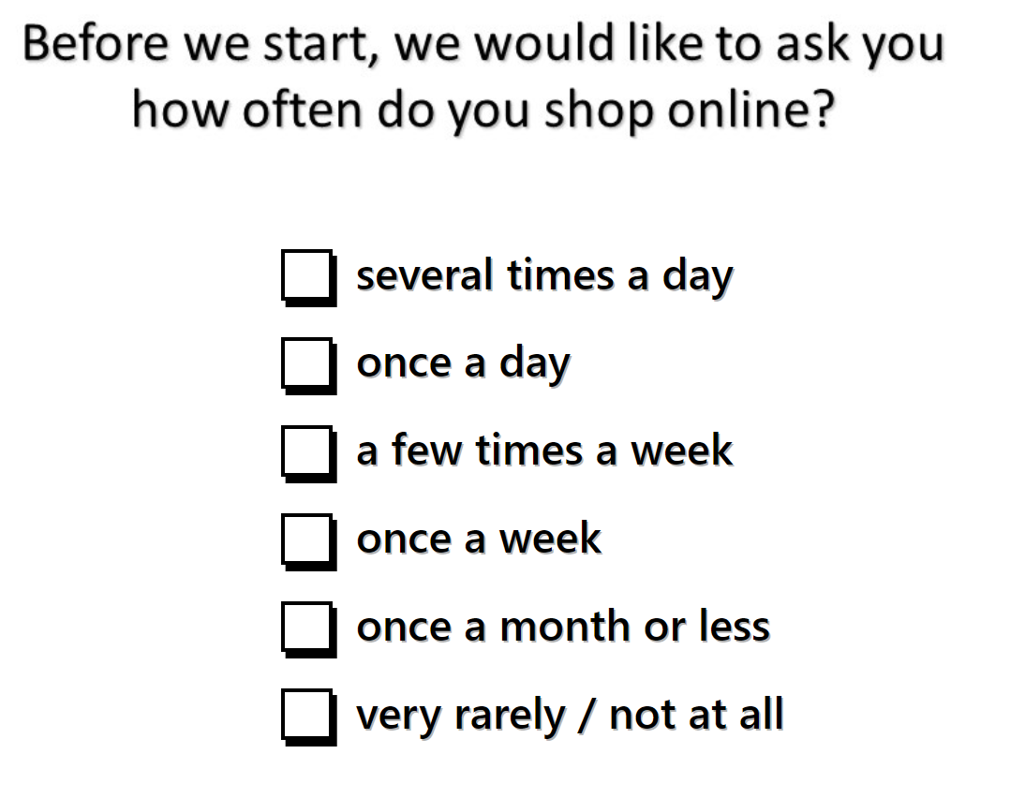

[x] PLEASE REMOVE NEXT BUTTONS WHEN NOT NEEDED. Rule:

* When participants make a response, i.e. tick an item or respond to VAS, then no NEXT button needed. Task moves on with participants response.
* Only include NEXT BUTTON when we need to know whether participant is ready, i.e. after instruction text, where no response is needed.

[x] The scrolling bar is not seen very well on the screen. Could this be made more visible?

[x] The categories should be never ending (both the categories with labels and the tiles within a category). When all categories have been shown, they start again from the top.

[x] Include Hashish category and price list. I sent it them the other day. Please let me know if you don’t have them.

[x] Include a few more categories (with price lists) to improve the range of items. Please set me know if you did not receive the categories that I sent you the other day.

[x] **Reduce the time for shopping in phase 1** from 15 minutes to 10 minutes – this requires a replacement of some instruction slides.

[x] **Replace the instruction slide in phase 2** – Trevor did not understand the instructions fully. We need to make some changes to the wording.

[x] Both lights in phase 2 should show equally often

[x] We noticed that some people press NEXT without reading the instructions. This is a problem. We need to have an option for the researcher to go back to the next slide and ask the participant to read the instructions. Roderick usually gives us the option of **Strg + B** to go one slide back. Could you please implement this as well.

Please let me know if you did not receive the new slides and the categories. I sent them to you in March 2024 via webtransfer.

[x] **Entry menu:** include a warning when the same ID number is entered twice. This is to make sure that the researcher does not make a mistake. If the ID number should be entered again, it is important that data are NEVER be overwritten.

[x] Bug: When participants pick the first item and then go back to the levels of the tile (after they clicked back/or added the item to the trolley), the item is not shown. This is because the computer places the item at a different place on the screen than the one that the participant ticked. This is very confusing.

[x] Check pseudorandomization of categories in the display on the screen.

[x] When an extra budget is added, please make sure that the item they selected issubtracted from the total amount. At the moment, the new amount is shown and they get the item for free.

[x] Show trolley icon also in the trolley page.

[x] Timer lags when Items are pressed —> Total shop duration exceeds 10 minutes.

[x] The cursor should go back to the place where participant opened the tile, not at the top. (Stop automatic scrolling to top after clicking item tile)

[x] Rename to „Remove from trolley“ and replace bin with checkbox

[x] All drugs should be represented in equal distribution.

[x] Add all relevant sounds. Please let me know if you do not have all the sounds.

[x] Only show items again when all items have been selected.

[x] Table in phase 3: add sound for positive and negative responses. Give participants time to see their responses, when all responses correct, play fanfare and give participants time to take a look at correct responses.

[x] Remove Next-Button from VAS slide – NEXT button not needed because participant makes a response.

[x] Category names: Cat over Accessories; ] To Go into Mugs to Go; Garden to Garden Accessories